Project Development Phase
Model Performance Test

Date | 17 February 2026
Team ID | LVIP2026TMIDSB7385
Project Name | AI Travel Itinerary Generator using Streamlit & Gemini API
Maximum Marks

Model Performance Testing:
S.No. | Parameter | Screenshot / Values
 | Data Rendered | User input data (destination, days, nights, interests) successfully captured through Streamlit UI and rendered correctly.  Rendered Fields:  • Destination text input  • Number inputs (days & nights)  • Interests input  • Generate button trigger  Result: Inputs correctly passed to AI model prompt.  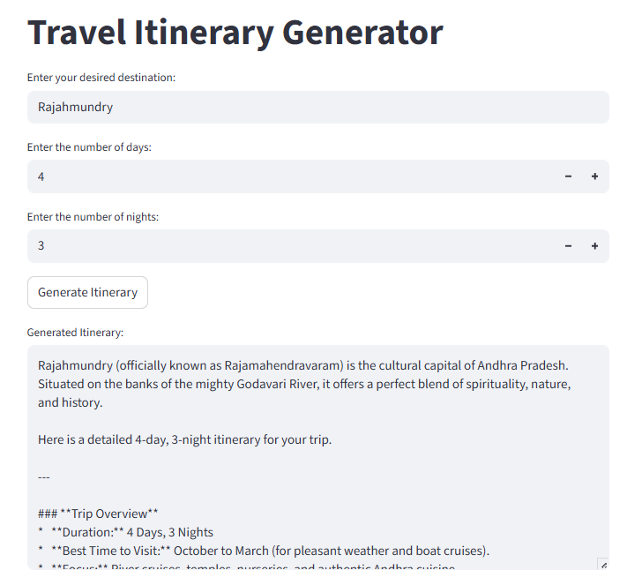
 | Data Preprocessing | Basic preprocessing applied to user inputs:  • Empty input validation  • Strip whitespace from destination text  • Numeric validation for days and nights  • Prompt formatting before sending to model  Result: Clean structured prompt sent to Gemini API.
3. | Utilization of Data Filters | User constraint filters applied inside prompt:  • Destination-based filtering  • Trip duration filtering  • Interest-based activity filtering  • Day-wise plan structuring  Model output adapts based on provided filters.
4. | DAX Queries Used | Not Applicable.  No DAX queries used.  Instead, prompt-engineered AI queries are used to dynamically generate itinerary content.
5. | Dashboard design | Streamlit interactive UI dashboard created.  Components:  • Input form  • Parameter controls  • Generate button  • Output itinerary panel  No of UI Components: 5+
6 | Report Design | Generated itinerary report is structured in:  • Day-wise sections  • Activity lists  • Food & travel tips  • Transport notes  • Travel recommendations  Output acts as a dynamic AI-generated travel report.

